Experiment No. 11

Experiment No. 11.1

Program to Save and Reload Machine Learning Model using Pickle

1. Aim
To train a machine learning model and demonstrate how to save and reload the trained model using the Pickle module in Python.

2. Objectives
- To understand model serialization in machine learning.
- To learn how to save a trained model using Pickle.
- To reload a saved model from a file.
- To perform predictions using the loaded model.
- To understand the importance of model persistence.

3. Software Required
- Python 3.x
- Jupyter Notebook / Google Colab / Anaconda
- Scikit-learn Library
- Pickle Module

4. Introduction
In machine learning, training a model can take significant time and computational resources. Instead of training the model every time, the trained model can be saved to a file and reused later.
Model serialization is the process of converting a trained model into a byte stream so that it can be stored on disk. Python provides the Pickle module for serialization and deserialization of Python objects.
- Serialization → Saving the model to a file
- Deserialization → Loading the model from a file
This technique is widely used in deployment, model sharing, reusability, and production systems.

5. Pickle Module
The Pickle module is used to:
- Save Python objects into files
- Load Python objects from files
Function | Purpose
pickle.dump() | Save object to file
pickle.load() | Load object from file

6. Steps in Model Serialization
- Import required libraries
- Create and train the machine learning model
- Save the trained model using pickle.dump()
- Load the saved model using pickle.load()
- Use the loaded model for prediction

7. Dataset Description
In this experiment, a small sample dataset is used. The dataset contains binary input combinations and corresponding output labels. Logistic Regression is used as the classification algorithm.
Input Features | Output
[0,0] | 0
[0,1] | 1
[1,0] | 1
[1,1] | 0

8. Dataset Characteristics
- Total number of records: 4
- Number of input features: 2
- Number of output classes: 2
- Type of problem: Classification

9. Learning Objective
The model learns the relationship between input features and output labels using Logistic Regression.

10. Program
import pickle
from sklearn.linear_model import LogisticRegression

X = [[0,0], [0,1], [1,0], [1,1]]
y = [0,1,1,0]

model = LogisticRegression()
model.fit(X, y)

with open("logistic_regression_model.pkl", "wb") as file:
pickle.dump(model, file)

print("Model saved successfully!")

with open("logistic_regression_model.pkl", "rb") as file:
loaded_model = pickle.load(file)

print("Model loaded successfully!")
prediction = loaded_model.predict([[1,0]])
print("Prediction:", prediction)

Output:
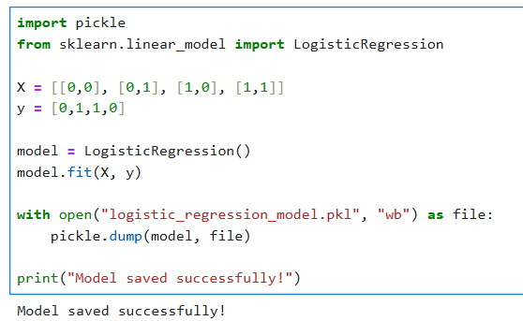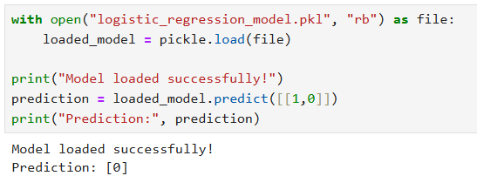

12. Output Explanation
- The Logistic Regression model is trained using sample data.
- The trained model is saved into a file named logistic_regression_model.pkl.
- The model is then reloaded from the file.
- Predictions made using the loaded model match the predictions of the original model.
- This confirms successful serialization and deserialization.

13. Result
The Logistic Regression model was successfully trained, saved using Pickle, reloaded from the saved file, and used for prediction.

14. Conclusion
Pickle is an efficient and simple method for saving and loading trained machine learning models. Model serialization helps in reusability, deployment, and reducing retraining time in real-world machine learning applications.

15. Viva Questions with Answers

1. What is model serialization?
Model serialization is the process of converting a trained machine learning model into a byte stream so that it can be stored in a file and reused later.

2. What is Pickle in Python?
Python Pickle is a built-in module used for serializing and deserializing Python objects. It helps save objects into files and load them back when needed.

3. What is the purpose of pickle.dump()?
The pickle.dump() function is used to save a Python object, such as a trained machine learning model, into a file.

Syntax
pickle.dump(object, file)

4. What is the purpose of pickle.load()?
The pickle.load() function is used to load a previously saved object from a file back into memory.

Syntax
pickle.load(file)

5. What is Logistic Regression?
Machine Learning Logistic Regression is a supervised machine learning algorithm used for classification problems. It predicts categorical outputs such as Yes/No or 0/1.

6. Why do we save trained models?
Trained models are saved to:
- Avoid retraining every time
- Reduce computation time
- Deploy models in real applications
- Share models with others
- Reuse models for future predictions

7. What is deserialization?
Deserialization is the process of converting stored byte-stream data back into the original Python object or machine learning model.

8. What file extension is commonly used for Pickle files?
The commonly used file extension for Pickle files is:
.pkl

9. Can Pickle store only machine learning models?
No, Pickle can store many types of Python objects such as:
- Lists
- Dictionaries
- Tuples
- Functions
- Machine learning models
- Custom objects

10. What are the advantages of model persistence?
Advantages of model persistence include:
- Faster predictions
- No need for retraining
- Easy deployment
- Model sharing
- Efficient reuse of trained models

Experiment No. 11.2

Program to Save and Reload Machine Learning Model using Joblib

1. Aim
To train a simple machine learning model and demonstrate how to save and reload the trained model using Joblib in Python.

2. Objectives
- To understand model persistence in machine learning.
- To learn how to save a trained model using Joblib.
- To reload a saved model from a file.
- To perform predictions using the loaded model.
- To understand the advantages of Joblib for machine learning models.

3. Software Required
- Python 3.x
- Jupyter Notebook / Google Colab / Anaconda
- Scikit-learn Library
- Joblib Library

4. Introduction
In machine learning, trained models are often saved for future use so that retraining is not required every time the application runs.
Model persistence allows trained machine learning models to be stored and reused later.
Joblib Joblib is a Python library commonly used for saving and loading machine learning models efficiently, especially models containing large NumPy arrays.

Advantages of Joblib
Feature | Benefit
Faster serialization | Efficient for large models
Memory optimization | Handles NumPy arrays efficiently
Easy model reuse | Reduces retraining time
Widely used | Common in Scikit-learn projects
Applications include:
- Machine learning deployment
- Model sharing
- Production systems
- Reusable AI applications

5. Joblib Module
Joblib provides simple functions for saving and loading models.
Function | Purpose
joblib.dump() | Save object to file
joblib.load() | Load object from file

6. Steps in Model Serialization using Joblib
- Import required libraries
- Create and train the machine learning model
- Save the trained model using joblib.dump()
- Load the model using joblib.load()
- Perform predictions using the loaded model

7. Dataset Description
- In this experiment, a small sample dataset is used.
- The dataset contains binary input combinations and output labels.
- A Random Forest Classifier is used for classification.

Dataset Table
Input Features | Output
[0,0] | 0
[0,1] | 1
[1,0] | 1
[1,1] | 0

8. Dataset Characteristics
- Total number of records: 4
- Number of input features: 2
- Number of output classes: 2
- Type of problem: Classification

9. Learning Objective
The model learns the relationship between input features and output labels using Random Forest Classification.
Machine Learning Random Forest combines multiple decision trees for prediction.

10. Program

import joblib
from sklearn.ensemble import RandomForestClassifier

X = [[0,0], [0,1], [1,0], [1,1]]
y = [0,1,1,0]
model = RandomForestClassifier()
model.fit(X, y)
joblib.dump(model, "random_forest_model.joblib")
print("Model saved successfully!")

loaded_model = joblib.load("random_forest_model.joblib")
print("Model loaded successfully!")
prediction = loaded_model.predict([[1,0]])
print("Prediction:", prediction)

Output:
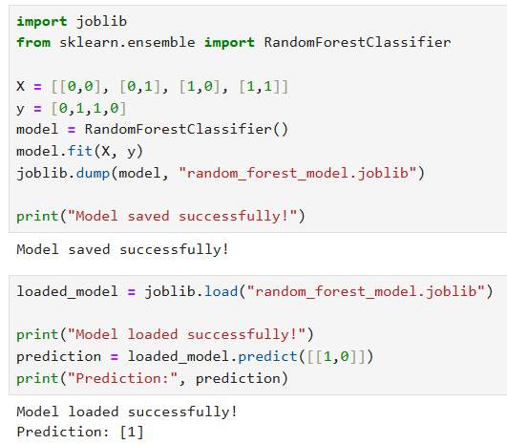

12. Output Explanation
- The Random Forest Classifier model is trained using sample data.
- The trained model is saved into a file named random_forest_model.joblib.
- The model is then loaded from the saved file.
- Predictions are made using the loaded model.
- The successful predictions confirm that the model was properly saved and restored.

13. Result
The Random Forest Classifier model was successfully trained, saved using Joblib, reloaded from the saved file, and used for prediction.

14. Conclusion
Joblib is an efficient library for saving and loading machine learning models, especially models containing large numerical arrays. It helps in model deployment, reusability, and reducing computational overhead in machine learning applications.

15. Viva Questions

1. What is model persistence?
Model persistence is the process of saving a trained machine learning model to a file so that it can be reused later without retraining.

2. What is Joblib?
Joblib Joblib is a Python library used for saving and loading machine learning models efficiently, especially models containing large NumPy arrays.

3. What is the purpose of joblib.dump()?
The joblib.dump() function is used to save a trained model or Python object into a file.

Syntax
joblib.dump(object, filename)

4. What is the purpose of joblib.load()?
The joblib.load() function is used to load a previously saved model or object from a file back into memory.

Syntax
joblib.load(filename)

5. What is Random Forest Classification?
Machine Learning Random Forest Classification is a supervised machine learning algorithm that combines multiple decision trees to improve prediction accuracy and reduce overfitting.

6. Why do we save machine learning models?
Machine learning models are saved to:
- Avoid retraining
- Reduce computation time
- Reuse trained models
- Deploy models in real-world applications
- Share models with others

7. What is serialization?
Serialization is the process of converting a Python object or machine learning model into a byte stream so that it can be stored in a file.

8. What file extension is commonly used for Joblib files?
The commonly used file extension for Joblib files is:
.joblib

9. What are the advantages of Joblib over Pickle?
Advantages of Joblib over Pickle:
- Faster for large models
- Efficient handling of NumPy arrays
- Better memory optimization
- Commonly used in Scikit-learn projects

10. Where is model persistence used in real-world applications?
Model persistence is used in:
- Machine learning deployment
- Production systems
- AI applications
- Recommendation systems
- Healthcare systems
- Fraud detection systems

